**People’s Democratic Republic of Algeria**

**Ministry of Higher Education and Scientific Research**

**Ibn Khaldoun University –Tiaret**

**Faculty of Mathematics and Computer**

**Science department**

Report N°1 on the practical work

Advanced Data Base and Data Mining

**Supervised By:**

**Mr Abdelkader OUARED**

**Presented by :**

* **Abdelhakim Azzouz**
* **Youcef Yslem Kharroubi**
* **Chaouki Nouar**

1. **MCD (CONCEPTUAL DATA MODEL)**

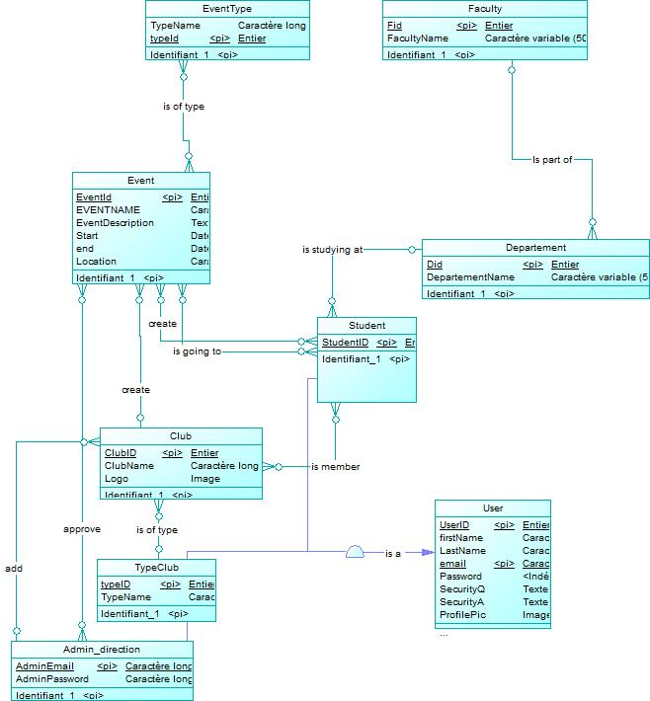

1. **MLD (LOGICAL DATA MODEL)**

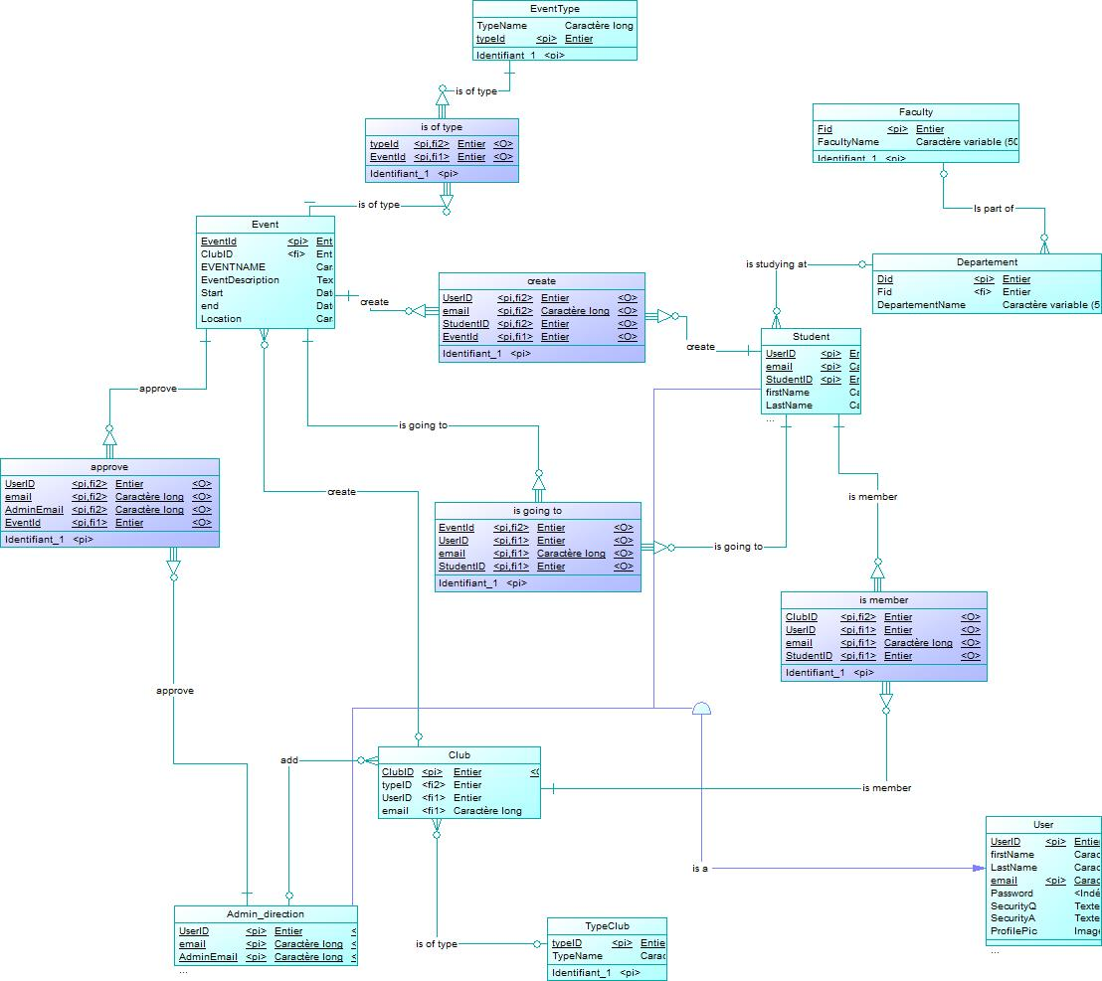

NOTE:

1. **MPD (PHYSICAL DATA MODEL)**

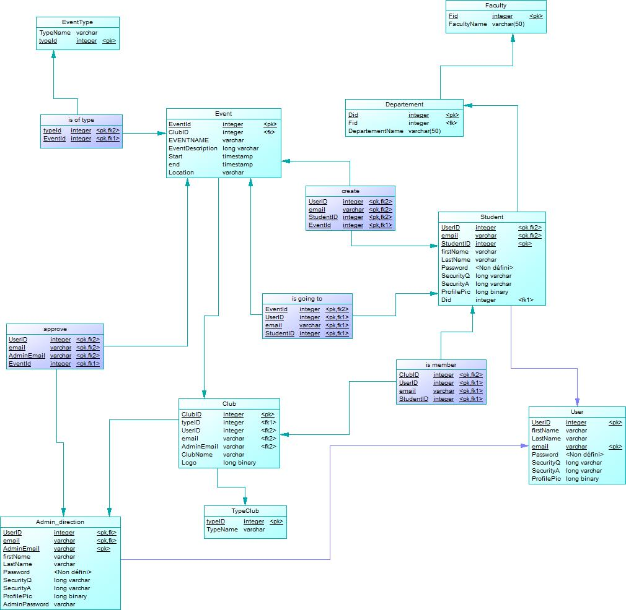

1. **Deployment:**

before choosing with SGBD is right for our system, we need to look for the best time of database that fulfills our need, in this situation we have 2 choices SQL type database to NoSQL type, to answer this question we need to look at the proprieties of both these database types.

**SQL VS NOSQL:**

SQL databases are relational, NoSQL are non-relational.

SQL databases use structured query language and have a predefined schema. NoSQL databases have dynamic schemas for unstructured data.

SQL databases are vertically scalable, NoSQL databases are horizontally scalable.

SQL databases are table based, while NoSQL databases are document, key-value, graph or wide-column stores.

SQL databases are better for multi-row transactions, NoSQL are better for unstructured data like documents or JSON.

For our database we will go for SQL database as it support ACID.

**The right SQL SGBD for this system is MySQL:**

**Why MySQL:**

1. Owned by Oracle: Although MySQL is free and open-source, the database system is owned and managed by Oracle.

2. Maturity: MySQL is an extremely established database.

3. Compatibility: MySQL is available for all major platforms

4. Cost-effective: The database is open-source and free.

5. Replicable: The MySQL database can be replicated across multiple nodes.

MySQL is a strong choice for any business that will benefit from its pre-defined structure and set schemas.

**Conclusion:**

A well-designed database is easier to use and maintain, making integration a breeze

A good database design can help save disk storage space by reducing data redundancy. Along with maintaining data precision and reliability, it allows us to access data in various ways.